**Appendix**

|  |  |
| --- | --- |
| ***Nomenclature*** | |
| ***A. Acronyms*** | |
| P2G | Power-to-gas |
| GG | Gas-fired generator |
| CG | Coal-fired generator |
| WT | Wind turbine |
| GW | Gas well |
| GC | Gas compressor |
| HS | Hydrogen storage |
| GCV | Gross caloric value |
| ***B. Indices and sets*** | |
| *t* | Index of time |
| *l* | Index of devices |
| *i*, *j*, *k* | Index of buses |
| *m*, *n*, *o* | Index of nodes |
| *e*(*j*), *e*(*n*) | Set of devices at bus *j* and node *n* |
| ΩEL, ΩCG, ΩWT | Set of lines, CGs, and WTs |
| ΩPL, ΩN, ΩB, | Set of pipelines, nodes, and buses |
| ΩP2G, ΩGG | Set of P2G facilities and GGs |
| ***C. Parameters*** | |
| , | Temperature and pressure in standard conditions |
| , | Gas constant of air and gas temperature |
| ,, | Length, friction factor, and diameter of pipeline *mn* |
|  | Gas flow limit of pipeline *mn* |
| , | Upper and lower pressure limits of node *m* |
| *GCV*ng, *GCV*hy, *GCV*me | GCVs of natural gas, hydrogen, and methane |
|  | Original gas demand of node *n* at time *t* |
| , | Specific gravity of natural gas and hydrogen |
| , | Critical temperature of natural gas and hydrogen |
| , | Critical pressure of natural gas and hydrogen |
| , | Upper and lower limits of compression ratios |
|  | Gas flow limit of GC between nodes *m* and *n* |
|  | Gas consumption ratio of GC between nodes *m* and *n* |
|  | Reactance of line *ij* |
|  | Power demand of bus *j* at time *t* |
|  | Power flow limit of line *ij* |
| , | Upper and lower limits of angle difference of line *ij* |
| , | Upper and lower limits of output power of CG *l* |
| , | Ramping up and down rates of CG *l* |
|  | Maximum output of WT *l* at time *t* |
|  | Limit of WT power curtailment |
| ,, | Efﬁciencies of electrolyzer *l*, methanation reactor *l*, and GG *l* |
|  | Capacity of P2G *l* |
| , | Input and output hydrogen limits in HS *l* |
| , | Upper and lower limits of stored hydrogen in HS *l* |
|  | Capacity of GG *l* |
| ,, | Carbon emission factors of CG *l*, GW *l*, and methanation reactor *l* |
| ,,, | Prices of fuel, gas production, wind power curtailment, and carbon emission |
| ***D. Variables*** | |
| , | Gas flows in pipelines *mn* and *no* at time *t* |
|  | Gas flow direction in pipeline *mn* at time *t* |
| , | Upper-stream node indicators |
| , | Pressures of nodes *m* and *n* at time *t* |
| , | Specific gravity of gas at nodes *m* and *n* at time *t* |
|  | Compressibility factor of gas in pipeline *mn* at time *t* |
|  | Natural gas supplied by GW *l* at time *t* |
| , | Hydrogen and methane injected at node *n* by P2G *l* at time *t* |
| , | Gas flows of GC between nodes *m*, *n* and nodes *n*, *o* at time *t* |
|  | Gas consumed by GC between nodes *m* and *n* at time *t* |
|  | Gas consumed by GG *l* at time *t* |
|  | Gas demand of node *n* at time *t* |
| ,, | GCV at nodes *m*, *n*, and *o* at time *t* |
| , | Hydrogen volume fraction of gas at node *m* and in pipeline *mn* at time *t* |
|  | Average pressure in pipeline *mn* at time *t* |
| , | Critical temperature and pressure of mixed gas in pipeline *mn* at time *t* |
|  | Compression ratio of GC between nodes *m* and *n* at time *t* |
| ,, | CG output power, GG output power, and wind power consumption at time *t* |
|  | Power supplied to P2G by WT *l* at time *t* |
|  | Curtailed power of WT *l* at time *t* |
| , | Power flows through lines *ij* and *jk* at time *t* |
|  | Angle difference of line *ij* at time *t* |
| , | Voltage angles at buses *i* and *j* at time *t* |
| , | Input and output hydrogen of HS *l* at time *t* |
|  | Stored hydrogen of HS *l* at time *t* |



**Fig. A1.** Topology structure of H-IEGS

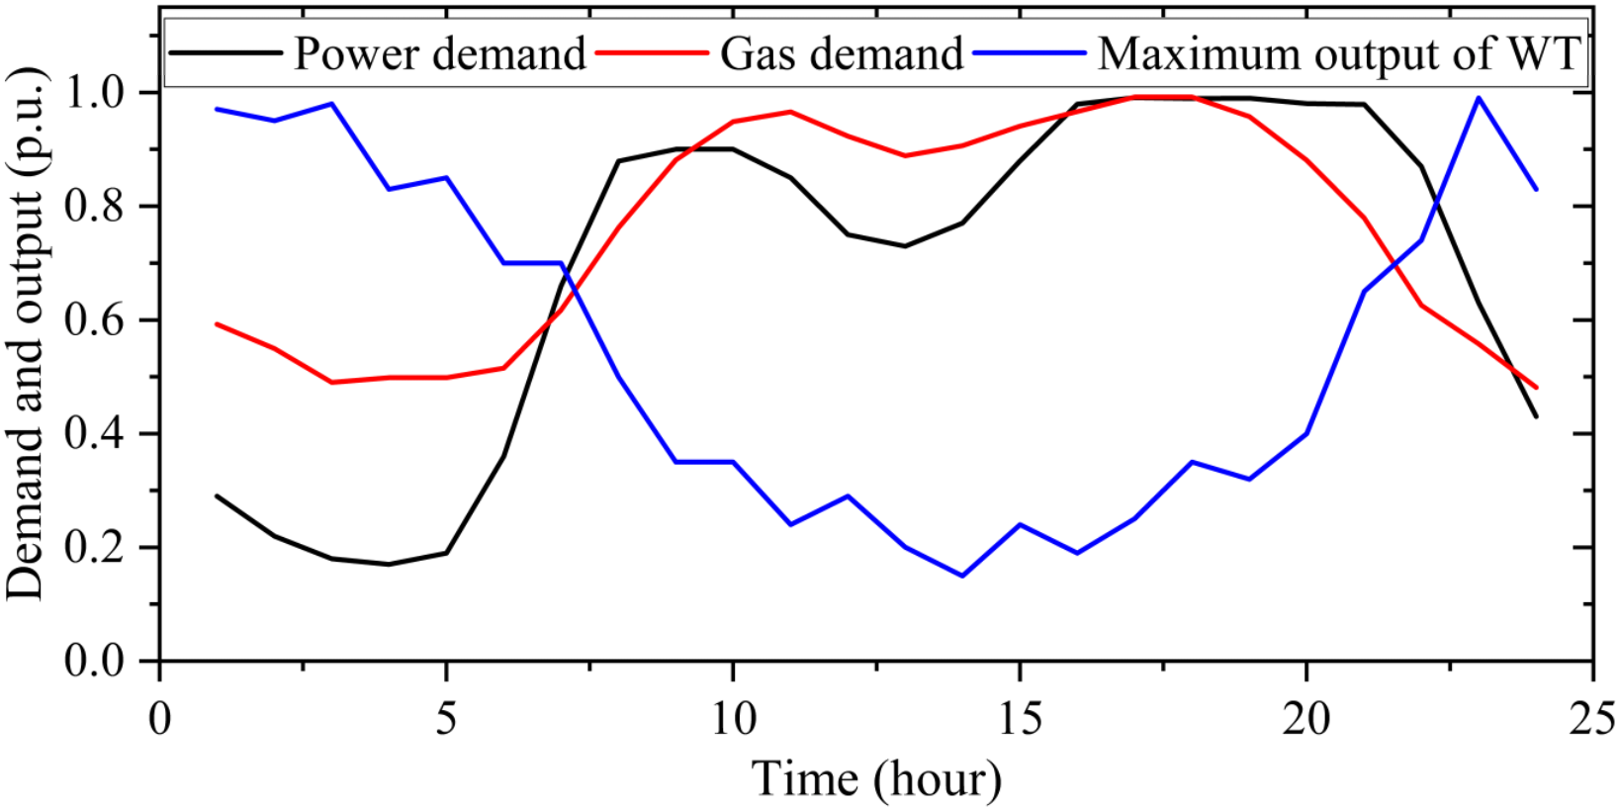

**Fig. A2.** Power demand, gas demand, and WT maximum output



**Fig. A3.** Iteration procedures of (a) PTR-SLP with hot start, (b) PTR-SLP with cold start, (c) NTR-SLP, and (d) FTR-SLP



**Fig. A4.** Variable gas properties in pipelines 8-12: (a) specific gravity, (b) compressibility factor, and (c) hydrogen volume fraction



**Fig. A5.** Pressure and gas flow differences in pipeline 8

|  |  |
| --- | --- |
|  |  |

**Fig. A6.** Comparison of wind power consumption in four models

|  |  |
| --- | --- |
|  |  |

**Fig. A7.** Comparison of gas production of P2G: (a) Model 1 and (b) Model 5

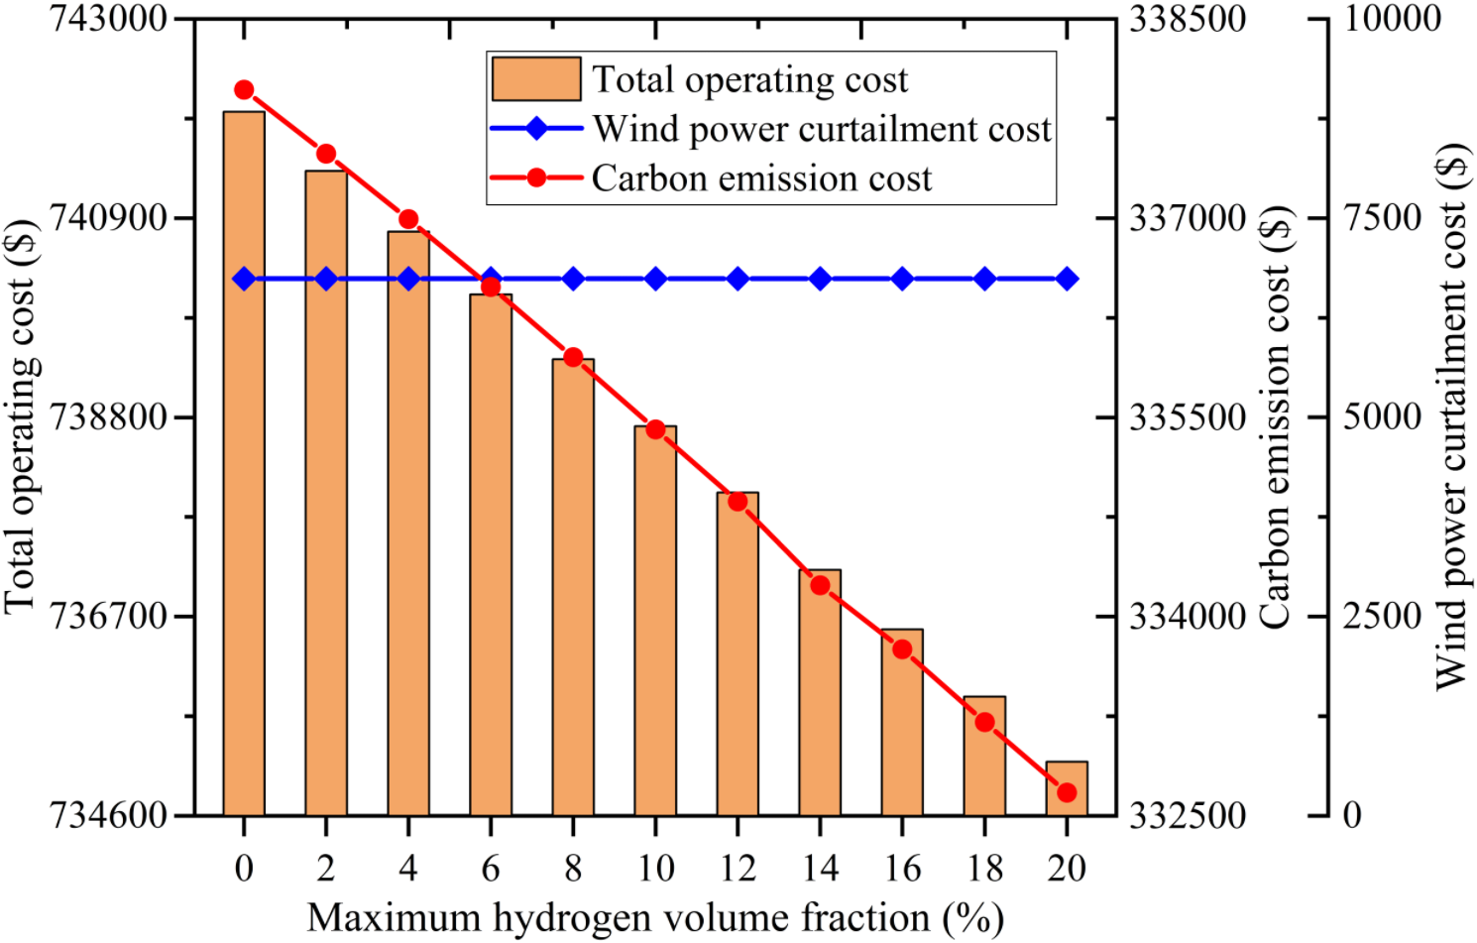

**Fig. A8.** Influence of different maximum hydrogen volume fractions

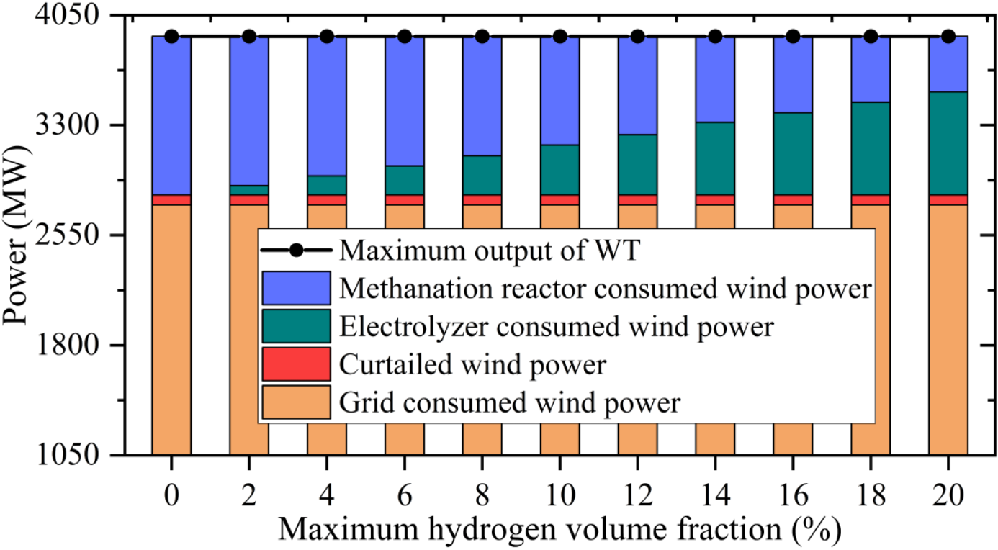

**Fig. A9.** Wind power utilizations for different hydrogen volume fractions

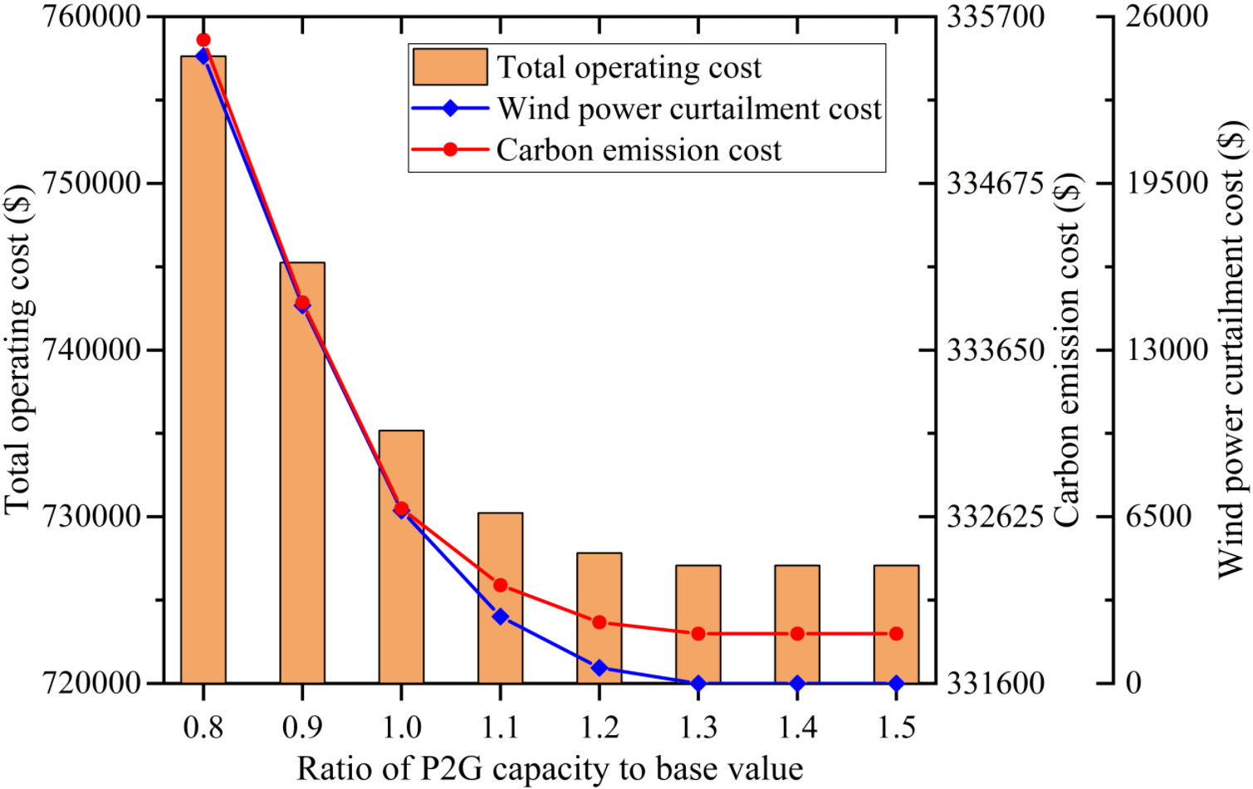

**Fig. A10.** Sensitivity analysis of P2G capacities

**Table A1**

Parameters of the power system

|  |  |  |  |  |
| --- | --- | --- | --- | --- |
| No. | From bus | To bus | Reactance (p.u.) | Power flow limit (MW) |
| L1 | 1 | 2 | 0.05917 | 110 |
| L2 | 1 | 5 | 0.22304 | 110 |
| L3 | 2 | 3 | 0.19797 | 110 |
| L4 | 2 | 4 | 0.17632 | 110 |
| L5 | 2 | 5 | 0.17388 | 110 |
| L6 | 3 | 4 | 0.17103 | 110 |
| L7 | 4 | 5 | 0.04211 | 110 |
| L8 | 4 | 7 | 0.20912 | 110 |
| L9 | 4 | 9 | 0.55618 | 110 |
| L10 | 5 | 6 | 0.25202 | 110 |
| L11 | 6 | 11 | 0.1989 | 110 |
| L12 | 6 | 12 | 0.25581 | 110 |
| L13 | 6 | 13 | 0.13027 | 110 |
| L14 | 7 | 8 | 0.17615 | 110 |
| L15 | 7 | 9 | 0.11001 | 110 |
| L16 | 9 | 10 | 0.0845 | 110 |
| L17 | 9 | 14 | 0.27038 | 110 |
| L18 | 10 | 11 | 0.19207 | 110 |
| L19 | 12 | 13 | 0.19988 | 110 |
| L20 | 13 | 14 | 0.34802 | 110 |

**Table A2**

Parameters of the natural gas system

|  |  |  |  |  |  |
| --- | --- | --- | --- | --- | --- |
| No. | From bus | To bus | Diameter (mm) | Length (km) | Gas flow limit (km3/h) |
| PI1 | 1 | 3 | 0.8 | 40 | 35 |
| PI2 | 2 | 4 | 0.8 | 40 | 35 |
| PI3 | 3 | 4 | 0.5 | 44 | 15 |
| PI4 | 3 | 5 | 0.7 | 50 | 30 |
| PI5 | 4 | 7 | 0.7 | 50 | 30 |
| PI6 | 6 | 9 | 0.7 | 50 | 30 |
| PI7 | 8 | 11 | 0.7 | 50 | 30 |
| PI8 | 10 | 13 | 0.6 | 40 | 20 |
| PI9 | 12 | 14 | 0.6 | 40 | 20 |
| PI10 | 13 | 14 | 0.5 | 46 | 15 |
| PI11 | 13 | 15 | 0.5 | 46 | 15 |
| PI12 | 14 | 15 | 0.5 | 46 | 15 |

**Table A3**

Parameters of CG

|  |  |  |  |  |
| --- | --- | --- | --- | --- |
| No. | Upper limit of output (MW) | Lower limit of output (MW) | Ramp up rate (MW/h) | Ramp down rate (MW/h) |
| CG1 | 130 | 15 | 26 | 26 |
| CG2 | 130 | 15 | 26 | 26 |
| CG3 | 120 | 15 | 24 | 24 |
| CG4 | 120 | 15 | 24 | 24 |

**Table A4**

Parameters of P2G

|  |  |  |  |  |  |
| --- | --- | --- | --- | --- | --- |
| No. | Capacity (MW) | Upper limit of input hydrogen in HS (km3/h) | Upper limit of output hydrogen in HS (km3/h) | Upper limit of stored hydrogen in HS (km3) | Lower limit of stored hydrogen in HS (km3) |
| P2G1 | 100 | 20 | 20 | 120 | 40 |
| P2G2 | 100 | 20 | 20 | 120 | 40 |

**Table A5**

Parameters of GG

|  |  |
| --- | --- |
| No. | Capacity (MW) |
| GG1 | 100 |
| GG2 | 100 |

**Table A6**

Parameters of GW

|  |  |  |
| --- | --- | --- |
| No. | Upper limit of supplied gas (km3/h) | Lower limit of supplied gas (km3/h) |
| GW1 | 15 | 5 |
| GW2 | 15 | 5 |
| GW3 | 15 | 5 |
| GW4 | 15 | 5 |

**Table A7**

Parameters of GC

|  |  |  |
| --- | --- | --- |
| Upper limit of the compression ratio | Lower limit of the compression ratio | Gas consumption ratio |
| 1.5 | 1 | 0.03 |

**Table A8**

Comparison between different solution methods

|  |  |  |  |
| --- | --- | --- | --- |
|  | PTR-SLP  with hot start | PTR-SLP  with cold start | IPOPT |
| Fuel cost of CGs ($) | 140704.52 | 140582.34 | 140704.51 |
| Gas production cost of GWs ($) | 255051.41 | 255953.19 | 255051.41 |
| Wind power curtailment cost ($) | 6740.49 | 6740.49 | 6740.49 |
| Carbon emission cost ($) | 332675.35 | 332977.29 | 332675.31 |
| Total operating cost ($) | 735171.77 | 736253.31 | 735171.72 |
| Computation time (s) | 6.28 | 15.50 | 152.50 |

**Table A9**

Results and computation time of other SLP methods

|  |  |  |
| --- | --- | --- |
|  | NTR-SLP | FTR-SLP |
| Fuel cost of CG ($) | 140704.51 | 140704.51 |
| Gas production cost of GW ($) | 255051.43 | 255051.43 |
| Wind power curtailment cost ($) | 6740.49 | 6740.49 |
| Carbon emission cost ($) | 332675.33 | 332675.33 |
| Total operating cost ($) | 735171.76 | 735171.76 |
| Computation time (s) | 68.60 | 25.43 |

**Table A10**

Results for constant gas properties

|  |  |
| --- | --- |
|  | Cost |
| Fuel cost of CGs ($) | 140704.52 |
| Gas production cost of GWs ($) | 255051.41 |
| Wind power curtailment cost ($) | 6740.49 |
| Carbon emission cost ($) | 332675.35 |
| Total operating cost ($) | 735171.77 |

**Table A11**

Different P2G production models

|  |  |  |
| --- | --- | --- |
| Model | Power to hydrogen | Power to methane |
| 1 | **√** | **√** |
| 2 | **√** | **×** |
| 3 | **×** | **√** |
| 4 | **×** | **×** |

**Table A12**

Results of different P2G models

|  |  |  |  |
| --- | --- | --- | --- |
|  | Model 2 | Model 3 | Model 4 |
| Fuel cost of CGs ($) | 143373.73 | 142260.51 | 150749.54 |
| Gas production cost of GWs ($) | 254254.76 | 255051.41 | 255885.26 |
| Wind power curtailment cost ($) | 35591.93 | 6740.49 | 117564.06 |
| Carbon emission cost ($) | 335265.02 | 337967.88 | 348005.66 |
| Total operating cost ($) | 768485.44 | 742020.29 | 872204.52 |

**Table A13**

Results of model 5

|  |  |
| --- | --- |
|  | Cost |
| Fuel cost of CG ($) | 150940.90 |
| Gas production cost of GW ($) | 250295.74 |
| Wind power curtailment cost ($) | 10576.19 |
| Carbon emission cost ($) | 350749.53 |
| Total operating cost ($) | 762562.36 |